UNIVERSITY OF MUMBAI

PRACTICAL ON

IMAGE PROCESSING

# SUBMITTED BY

SURAJ YADAV

Application Id:- 172756



D.T.S.S. College of Commerce

Subject Teacher name

# Mr. Chirag Deora MCA. I [2022-23]



UNIVERSITY OF MUMBAI

INSTITUTE OF DISTANCE AND OPEN LEARNING (IDOL)

CERTIFICATE

THE EXPERIMENTS DULY SIGNED IN THIS PROJECT REPORT REPRESENT THE BONAFIDE

WORK BY MR. SURAJ YADAVAPPLICATION ID / SEAT NO. 172756 IN

SEMESTER II OF FIRST YEAR OF MASTER OF COMPUTER APPLICATION (FYMCA

1YRS) OF PCP CENTER DTSS COLLEGE MALAD (EAST) FOR IMAGE PROCESSING PRACTICAL DURING THE ACADEMIC YEAR 2021-2022.

LECTURE IN CHARGE HEAD OF DEPARTMENT COURSE IN CHARGE

Examiner _______________

Date: __________ DTSS College Seal

INDEX

|  |  |  |  |
| --- | --- | --- | --- |
| MODULE NO. | PG. NO. | TOPIC | REMARK |
| 1 | 04 | Median Filter in MATLAB to remove Salt & Pepper noise. |  |
|  |  |  |
| 2 | 06 | MATLAB program for Deblur Images Using a Wiener  Filter |
|  |  |  |
| 3 | 07 | MATLAB program for Image Negation. |
|  |  |  |
| 4 | 08 | Edge Detection using Sobel, Prewitt and Roberts Operators. |
|  |  |  |
| 5 | 09 | MATLAB program for morphological operations on binary images. |
|  |  |  |
| 6 | 11 | Image Smoothening and Sharpening |
|  |  |  |
| 7 | 12 | MATLAB program for Scaling & Rotation Scaling (Resize). |
| 8 | 13 | MATLAB program for edge detection, gray level Thresholding in Image Segmentation. |
| 9 | 15 | Write a program on Discrete Cosine Transform. |

# PRACTICAL NO: -1

AIM: Median Filter in MATLAB to remove Salt & Pepper noise.

|  |
| --- |
| clc;  clear all  I = imread('C:\Users\admin\Pictures\desktop.jpg');  K = rgb2gray(I);  J = imnoise(K, 'salt & pepper', 0.05);  [m, n] = size(J);  *//d = zeros(m, n); % Initialize the output image*  for i = 2: m-1  for j = 2: n-1  d(i, j) = median([J(i-1, j+1), J(i, j+1), J(i+1, j+1); J(i-1, j), J(i, j), J(i+1, j); J(i-1, j), J(i, j-1), J(i+1, j-1)]);  end  end  subplot(3, 2, 1);  imshow(I);  title('Original Image');  subplot(3, 2, 2);  imshow(K);  title('Gray Image');  subplot(3, 2, 3);  imshow(J);  title('Noise added Image');  subplot(3, 2, 4);  imshow(d);  title('3x3 Image'); |

OUTPUT:

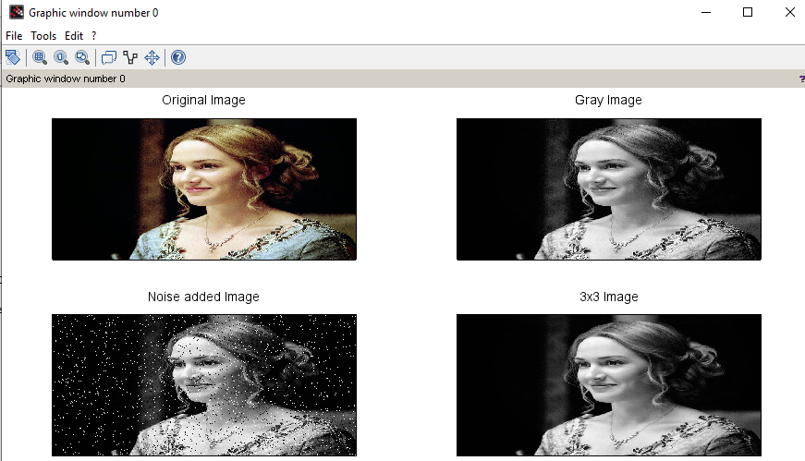

PRACTICAL NO: -2

AIM: MATLAB program for Deblur Images Using a Wiener Filter.

Code:

|  |
| --- |
| clc;  clear all;  Ioriginal = imread('C:\Users\admin\Pictures\MT 15 2 Final.jpg');  subplot(1,3,1);  imshow(Ioriginal);  title('Original Image');  PSF = fspecial('motion',21,11);  Idouble = im2double(Ioriginal);  blurred = imfilter(Idouble, PSF, 'conv', 'circular');  subplot(1,3,2);  imshow(blurred);  title('Blurred Image');  wnr1 = deconvwnr(blurred, PSF);  subplot(1,3,3);  imshow(wnr1);  title('Restored Blurred Image'); |

OUTPUT: -

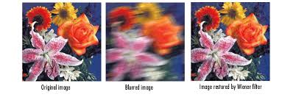

PRACTICAL NO: -3

AIM: MATLAB program for Image Negation.

Code:

|  |
| --- |
| clc; clear all;  a = imread('C:\Users\admin\Pictures\MT 15 2 Final.jpg')  subplot(1,2,1);  imshow(a);  title('Bike');  b = 255-a;  subplot(1,2,2);  imshow(b);  title('Negation of Bike'); |

Output:-

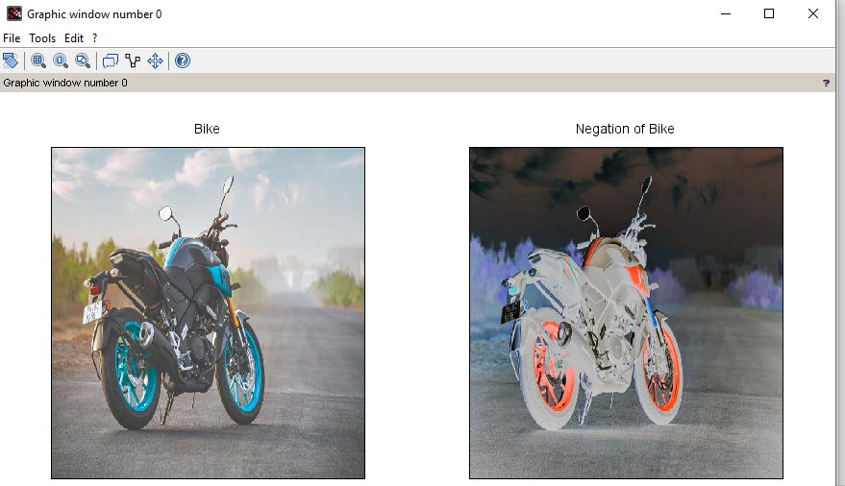

PRACTICAL NO: -4

AIM: Edge Detection using Sobel, Prewitt and Roberts Operators. Code : edge.m

|  |
| --- |
| clc;  clear all;  close all;  a = imread('rose.jpg');  b = rgb2gray(a);  subplot(2,2,1);  imshow(a);  title('Original Image');  c1 = edge(b,'sobel');  subplot(2,2,2);  imshow(c1);  title('Sobel Operator');  c2 = edge(b,'prewitt');  subplot(2,2,3); imshow(c2);  title('Prewitt Operator');  c3 = edge(b,'roberts');  subplot(2,2,4);  imshow(c3);  title('Roberts Operator'); |

Outpu

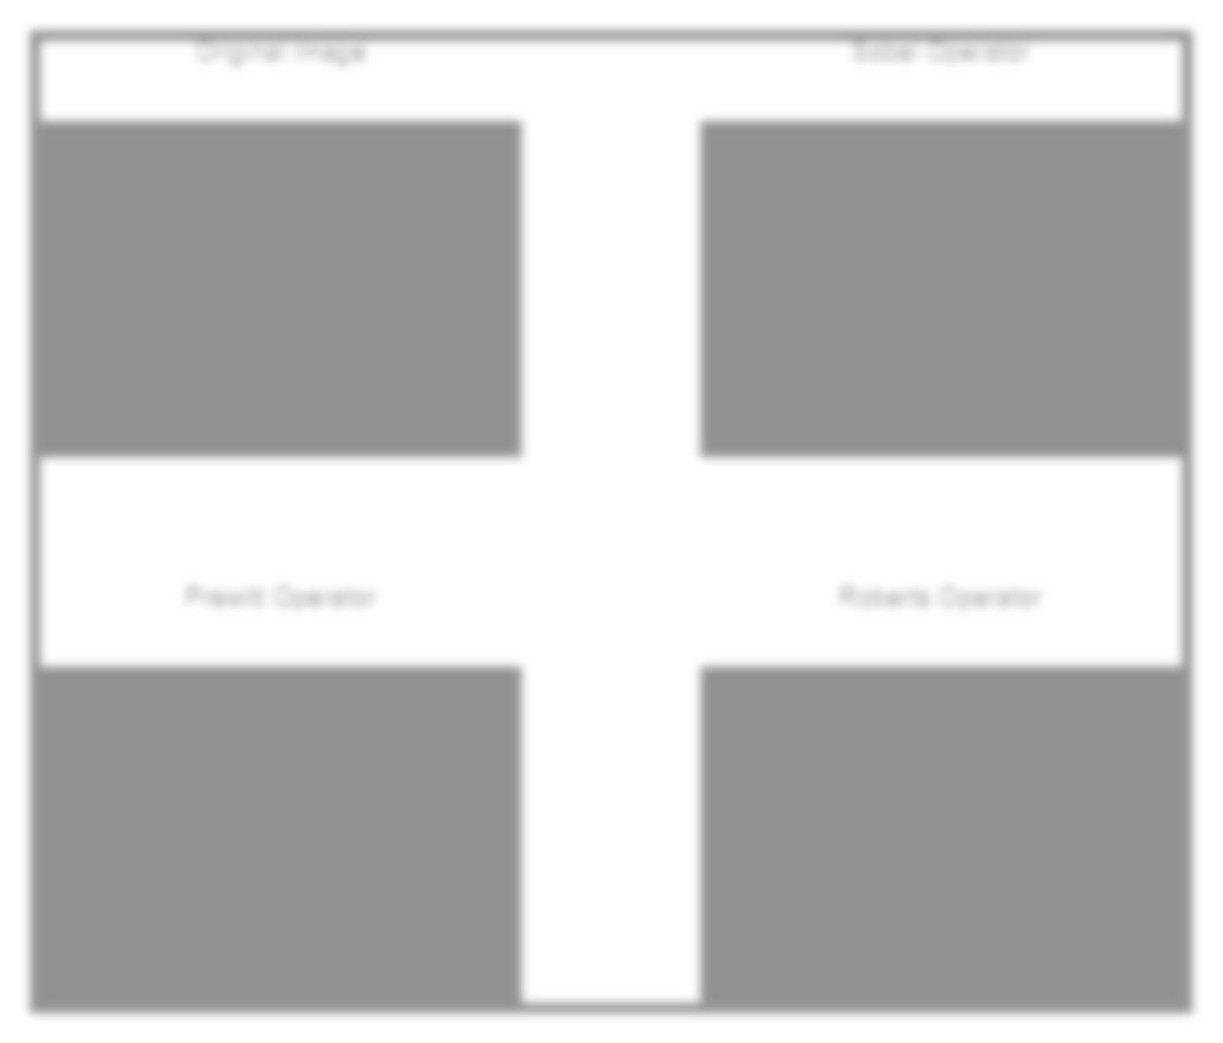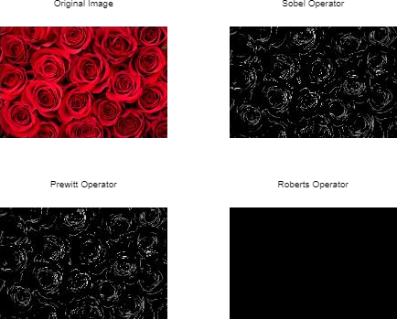

PRACTICAL NO: -5

AIM: MATLAB program for morphological operations on binary images.

Code: # Importing the image

|  |
| --- |
| clc;  clear all;  I = imread("C:\Users\admin\Pictures\Rose.jpeg");  subplot(2, 3, 1),  imshow(I);  title("Original image");  *//% Dilated Image*  se = strel("line",7,7);  dilate = imdilate(I, se);  subplot(2,3,2),  imshow(dilate);  title("Dilated image");  *// Eroded image*  erode = imerode(I, se);  subplot(2, 3, 3),  imshow(erode);  title("Eroded image");  *//Opened image*  open = imopen(I, se);  subplot(2, 3, 4),  imshow(open);  title("Opened image");  *// Closed image*  close = imclose(I, se);  subplot(2, 3, 5),  imshow(close);  title("Closed image"); |

OUTPUT: -

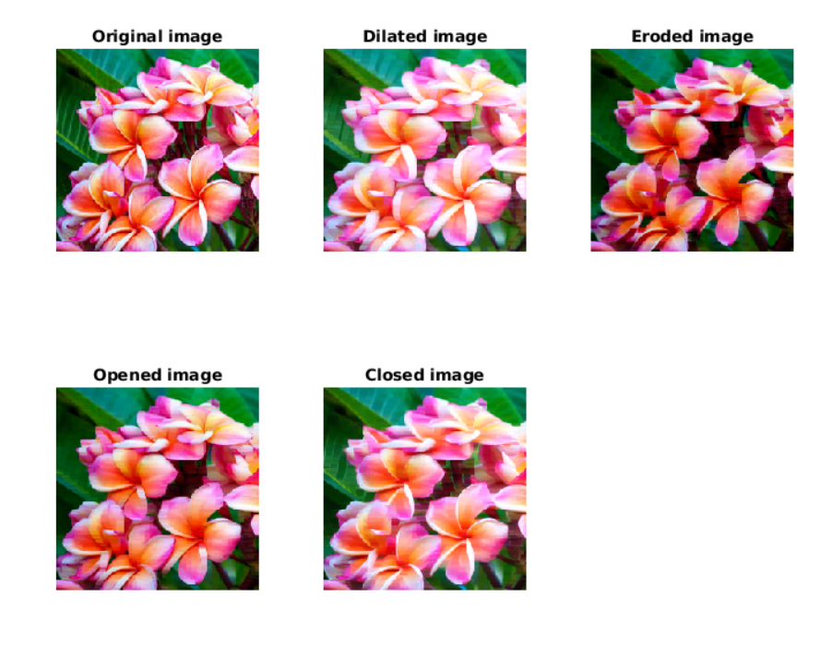

# 

PRACTICAL NO: -6

# Aim:- Image Smoothening and Sharpening

Code: Smoothening.m clc;

|  |
| --- |
| clc;  clear all;  a=imread('C:\Users\admin\Pictures\desktop.jpg');  subplot(1,3,1);  imshow(a);  title('original image');  h = fspecial('gaussian');  b = imfilter(a,h);  subplot(1,3,2);  imshow(b);  title('smoothened image');  c = imsharpen(a);  subplot(1,3,3);  imshow(c);  title('sharpened image'); |

# Output:-

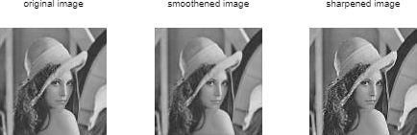

# PRACTICAL NO: -7

AIM: MATLAB program for Scaling & Rotation Scaling (Resize).

Code:

|  |
| --- |
| clc;  clear all;  I = imread("C:\Users\admin\Pictures\birds.jpg");  subplot (2,2,1);  imshow(I);  title('Original Image');  s= input ('Enter Scaling Factor');  j=imresize (I,10);  subplot (2,2,2);  imshow(j);  title('Scaled Image');  K= imrotate (I,45);  subplot (2,2,3);  imshow (K);  title('Rotated Image 45deg');  R =imrotate (I,180);  subplot (2,2,4);  imshow (R);  title('Rotated Image 180deg'); |

OUTPUT:

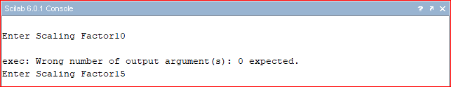

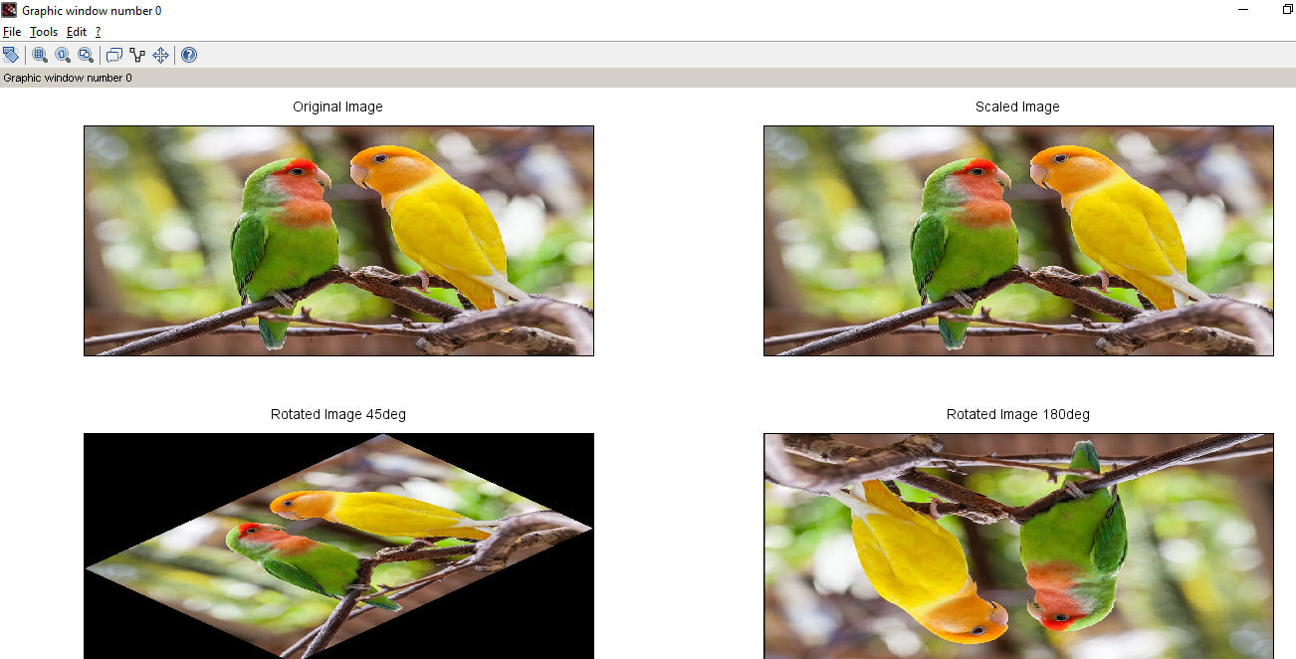

# PRACTICAL NO: -8

AIM: MATLAB program for edge detection, gray level Thresholding in Image Segmentation.

Code: -

% Following MATLAB function will take a grayscale

% or an RGB image as input and will return a

% binary image as output

|  |
| --- |
| function [binary] = convert2binary(img)       [x, y, z]=size(img);       % if Read Image is an RGB Image then convert       % it to a Gray Scale Image For an RGB image       % the value of z will be 3 and for a Grayscale       % Image the value of z will be 1      if z==3           img=rgb2gray(img);      end      % change the class of image      % array from 'unit8' to 'double'      img=double(img);      % Calculate sum of all the gray level      % pixel's value of the GrayScale Image      sum=0;      for i=1:x           for j=1:y          sum=sum+img(i, j);       end       end      % Calculate Threshold value by dividing the      % calculated sum by total number of pixels      % total number of pixels = rows*columns (i.e x*y)      threshold=sum/(x*y);      % Create a image array having same number      % of rows and column as Original image      % with all elements as 0 (Zero).      binary=zeros(x, y);      % iterate over all the pixels of Grayscale      % Image and Assign 1 to binary(i, j), if gray      % level value is >=  threshold value      % else assign 0 to binary(i, j)      for i=1:x       for j=1:y          if img(i, j) >= threshold                  binary(i, j) = 1;          else              binary(i, j)=0;          end       end      end  end  % driver function  % Read the target Image  img=imread('apple.png');  % Call convert2binary() function to convert  % Image to binary using thresholding  binary_image=convert2binary(img);  % Display result  imshow(binary_image); |

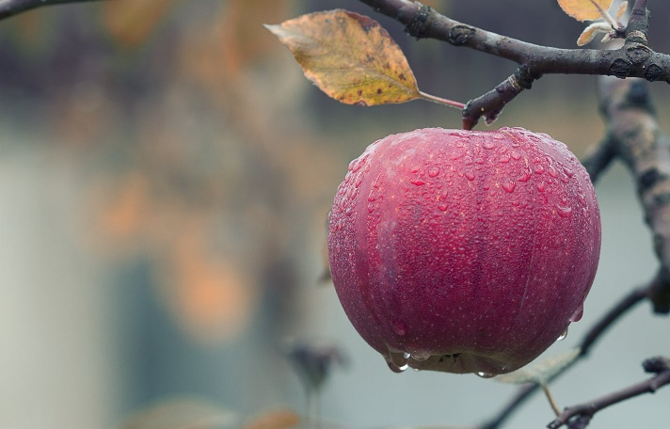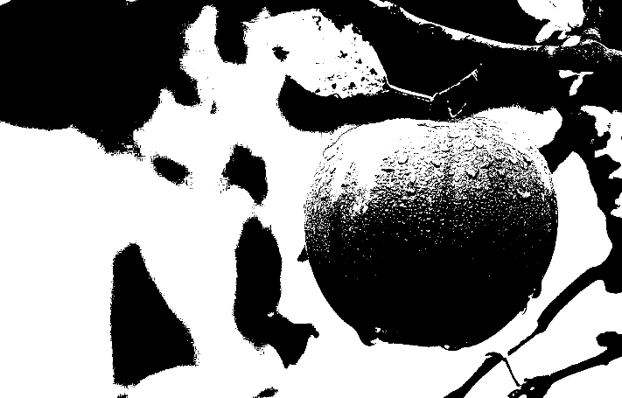OUTPUT: -

Practical no: 9

Aim: Write A program on Discrete cosine Transform

Code:

|  |
| --- |
| import java.util.*;  class GFG  {  public static int n = 8,m = 8;  public static double pi = 3.142857;  static strictfp void dctTransform(int matrix[][])  {  int i, j, k, l;  double ci, cj, dct1, sum;  for (i = 0; i < m; i++)  {  for (j = 0; j < n; j++)  {  if (i == 0)  ci = 1 / Math.sqrt(m);  else  ci = Math.sqrt(2) / Math.sqrt(m);  if (j == 0)  cj = 1 / Math.sqrt(n);  else  cj = Math.sqrt(2) / Math.sqrt(n);  sum = 0;  for (k = 0; k < m; k++)  {  for (l = 0; l < n; l++)  {  Math.cos((2 * l + 1) * j * pi / (2 * n));  }  dct1 = matrix[k][l] *Math.cos((2 * k + 1) * i * pi / (2 * m)) *  sum = sum + dct1;  }  dct[i][j] = ci * cj * sum;  }  }  for (i = 0; i < m; i++)  {  for (j = 0; j < n; j++)  System.out.printf("%f\t", dct[i][j]);  System.out.println();  }  }  public static void main (String[] args)  {  int matrix[][] = { { 255, 255, 255, 255, 255, 255, 255, 255 },  {255, 255, 255, 255, 255, 255, 255, 255},  {255, 255, 255, 255, 255, 255, 255, 255},  {255, 255, 255, 255, 255, 255, 255, 255},  {255, 255, 255, 255, 255, 255, 255, 255},  {255, 255, 255, 255, 255, 255, 255, 255},  {255, 255, 255, 255, 255, 255, 255, 255},  {255, 255, 255, 255, 255, 255, 255, 255}};  }  }  dctTransform(matrix); |

Output;-

